Front-end Interview Project

The goal of this exercise is to evaluate your UI/UX skills, coding style, and application of best practices.

The task is to develop a simple web application from start to finish using the technologies and frameworks or libraries you are familiar with.

**Requirements**

The project consists of two parts.

1. The application
2. A styled UI component

**Part 1.**

A wireframe mockup is provided.

The application should include the entities described below.

**Entities**

* Security (for example, Stock, Bond, etc.)
  + Security Name
  + ISIN
  + Country
* Security Price – list of prices for each security, there is only one entry per day per security
  + Date
  + End of Day price

The application UI should support the following use cases

**Use Cases**

* Add/Edit/Delete security
* View list of securities
* Add/Edit/Delete price for a security
* View a list of security prices

The application should be done completely on the client side (no back end required), with adding/editing/deleting of securities and prices saved on the front-end in JavaScript objects.

**Part 2.**

A flattened PNG of the design is provided.

The deliverable should be HTML and CSS and should meet the following criteria

**Criteria**

* Exact/pixel perfect translation of design
* Consideration of real-world application of the code you will write. i.e. made reusable such that, should you be asked, the application of Part 1. could be styled accordingly with minimal refactoring

**Deliverables**

You should deliver a package with simple instructions on how to set it up and run it.

**Part 1. Wireframe**

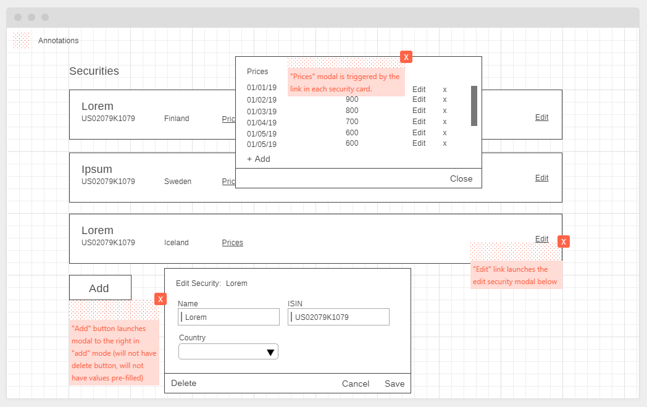

**Part 2. Design**

